

**1.0 CALL TO ORDER**

Vice-President Bruce Hawkshaw called the 17th annual general meeting of the Mature Action Committee of Whistler to order at 7:10 p.m. Vice-Pres. Hawkshaw welcomed members and guests to the meeting, and introduced the executive members at the table: Mark Watson (treasurer), Marg Pallot (membership), and Sue Lawther (president).

**2.0 APOLOGIES**

none

**3.0 VALIDATION AND QUORUM**

Vice-Pres. Hawkshaw confirmed notice of the meeting was posted in local newspapers and the notice and the agenda were circulated to MAC members and placed on MAC website in compliance with requirements.

Membership Chair confirmed attendance of over 30% members in good standing which exceeded the required quorum of 20% and the meeting lawfully opened.

**4.0 MINUTES OF PREVIOUS MEETING – March 28, 2011**

It was moved by S. Stangel, seconded by G. Watson, that the Minutes be approved as circulated. Motion carried.

**5.0 REPORTS**

**5.1 President’s Report** (S. Lawther)

Our path remains much the same, as we progress towards our long term goal – that is making Whistler a place where seniors can ‘age comfortably in-place’ - and our focus includes both the creation of more affordable housing for seniors, and meeting the health and social needs of seniors in our community

* our MEMBERSHIP keeps growing, now numbering 246 individuals, as seniors continue to be the fastest growing demographic in Whistler
* ACTIVITIES such as the Seniors Ski Team & Seniors Fitness Classes are on-going successes, and we look forward to the start-up of a Seniors’ Drop In Centre at the WBF Social Services Centre in early July (every Thursday from 1-3 p.m.)
* MAC continues to partner with the RMOW and are in discussions currently to form a Seniors Advisory Council with RMOW representation
* And of course our members are always busy volunteering throughout our community – in the village, on the mountains, and most recently for the new trails rehabilitation project
* Our COMMUNICATIONS will be undergoing a redesign this year. I will touch on in a moment, but I did not want to let this moment slip by without recognizing our webmaster, Don Armour, who not only catches the curve balls I keep throwing at him but also get all the data into a web format and onto our website in a timely manner (I am not good at giving him a decent lead time … usually 5 minutes ago is about all he gets!!!).
* Also, we count on you to keep us advised as to any changes in your street and e-mail addresses, so we can stay in touch
* Our SENIOR’S NEEDS ASSESSMENT GROUP remains active, and they ARE finding ways to ensure active ageing here in Whistler … let’s have a look at what they are up to …



Specific activities this year have included:

* Town Hall Meeting in March was a huge success and opened a community-wide dialogue on ageing in place in Whistler
* Second annual senior’s lifestyle fair last October was also a success with attendance numbers up from last year
* again submitted a grant application under New Horizons,
* and will be seeking funding for an online communication centre for all seniors in Whistler from the WB Foundation
* Freda represents us on the Measuring Up Select Committee of Council, to help make Whistler more inclusive and accessible; Freda is now only in Whistler 6 months of the year and we are seeking a replacement to keep our chair on this committee
* Senior’s Centre … we are thrilled to announce that we have been successful in our grant application with New Horizons for Seniors! We have been granted $16,000 as seed monies for a start-up intergenerational senior’s centre and a redesign of our website. We have just heard (yesterday) and will be meeting to get that project underway
* The goal for 2012 is to build critical mass by the following:
* Advocate for a senior’s advisory committee at Municipal level
* Work with RMOW to strengthen ties between MAC and RMOW (make them aware what MAC is doing and Melissa is achieving)
* Make MAC the ‘go-to’ source for what is happening with Whistler’s Seniors
* Work on driving more people to MAC’s website (3764 visits in 2011)
* Get the word out about available senior’s services and MAC
* Increase awareness of MAC in the community and recruit new MAC members
* MAC branding
* MAC – name change or branding?
* Communicating to all seniors in the community (not just MAC members) the programs and services that are available in the community
* Ask for column in local papers with a senior focus
* Cultivate a more inclusive senior image. MAC is not just housing.
  + Awareness
  + Education (ageing and needs)
  + Opportunities
* And last but not least, an UPDATE on SENIORS HOUSING -
* MAC Directors are always looking for ‘seniors’ housing opportunities in Whistler, consulting with both RMOW planners and developers as needed. One of our Directors, Gord Leidal, has had a presence on the Whistler Housing Authority [WHA] Board for the past 6 years.
* Three locations: [1] Cheakamus Crossing, located at the south end of Whistler; [2] the Rainbow Lands, located immediately north of Alpine Meadows; and [3] the Holborn Property located north of Lorimer Road at the north end of Northlands Boulevard.
* At Cheakamus Crossing
* In the spring of 2008 the Whistler Housing Authority allocated 24-units for seniors housing at Cheakamus Crossing, including 6 townhome and 18 apartment style units, with occupancy in the fall of 2010. While undersubscribed originally, 9 of those units are now owned & occupied by Whistler seniors, with the remainder owned & occupied by Whistler residents from the WHA waitlist. On resale for any of those 24 units, they will first be offered to qualified Whistler seniors, with all MAC members notified at the time of a re-sale. All of these units are both occupancy and price restricted.
* At Rainbow
* There are two relatively large lots at Rainbow zoned for seniors housing.
* Lot 11 at Rainbow is owned by the Innovation Building Group, and it is zoned for a maximum of 20 ‘seniors occupancy restricted market-priced’ housing units, to be priced capped after the first sale. Previously known as ‘The Woods at Rainbow’, the development may comprise apartment style units with exterior entries in a 3-storey building over an underground parking garage., The project was marketed during the latter part of 2010 based on a preliminary design completed in 2009. Due to insufficient interest at that time, however, the development did not proceed. Delivery timelines remain uncertain.
* Lot 10 at Rainbow is owned by RMOW, and it is zoned for a maximum of 20 'seniors occupancy and price restricted' units’. The results from a November 2010 Seniors Housing Needs Assessment survey prepared by the WHA & MAC seemed to indicate a relatively high level of interest and commitment for this housing project. With the help of seed funding from CMHC, some preliminary architectural work and pricing by a quantity surveyor was completed on the basis of an apartment style complex in a 3 storey building over an underground parking garage. In a follow-up April 2011 WHA-MAC survey specific to this proposal, complete with preliminary pricing [e.g. net cost per saleable area about $330 per sq. ft.], there was insufficient interest to allow the project to proceed.
* In August 2011, and again with the help of CMHC seed funding, preliminary architectural work was completed for an alternative 8-unit townhome complex specifically designed for seniors and complete with covered parking. The quantity surveyor confirmed saleable area pricing to be in the order of $348 per sq. ft. From an October 2011 WHA-MAC survey specific to this townhome project, it was again confirmed that there was insufficient purchasers ready to commit to the project at that time. General feedback indicated that the pricing and unit design was desirable, but uncertainty in the housing market and in people’s personal lives made it difficult to commit to a project that was 2 years away from completion.
* At the November 2011 WHA Board meeting it was recommended that consideration be given to revisiting the opportunity for seniors housing on Rainbow Lot 10 sometime in 2012.
* The proposed Rainbow commercial area on Lot 9 includes resident restricted housing above, and the Developer has suggested including some seniors housing within this project
* At Holborn
* With its location in proximity to Village North, the Marketplace and the Medical Centre, Whistler’s seniors have shown a high level of interest in this potential development. The plan provides for 20 to 22 'seniors occupancy & price restricted' apartment style units. In addition a seniors’ centre [or meeting place] would be included as a community amenity. The proposed development rezoning and sub-division is ready for a fourth and final reading from Council, and has been for several years.
* Very recently the Developer approached RMOW staff with the objective to review and revise the current re-zoning proposal. It is the hope of MAC that there will be an opportunity here to not only secure the building of seniors housing with a seniors centre, but also at pre-set maximum unit prices that are considered affordable.
* What About Rental Housing?
* While one of our goals has always been to create some rental units, it continues to represent a huge challenge to secure the necessary equity financing in today’s economy; there are no senior’s housing rental projects contemplated at this time. There is another option for rental housing, however, as the WHA does have a fairly large inventory of rental apartment units located throughout our community; while not specifically allocated for seniors, some MAC members may be eligible and could apply to be on the WHA rental waitlist as ‘Whistler Retirees’
* Also our thanks goes to Marla & Jessica at the WHA for their continuing support
* And once again our thanks goes out to all of you for being here today.

It was moved by G. Leidal, seconded by D. Deeks, that the President’s Report be accepted. Motion carried.

**5.2 Treasurer’s Report** (Mark Watson)

Treasurer Watson first recognized past Treasurer, Doug Deeks, and thanked him for all his hard work over many years of service. Treasurer Watson also thanked the Board and Doreen Watson for their assistance during this transition year.

Treasurer Watson then provided a review of the revenue and expenses:

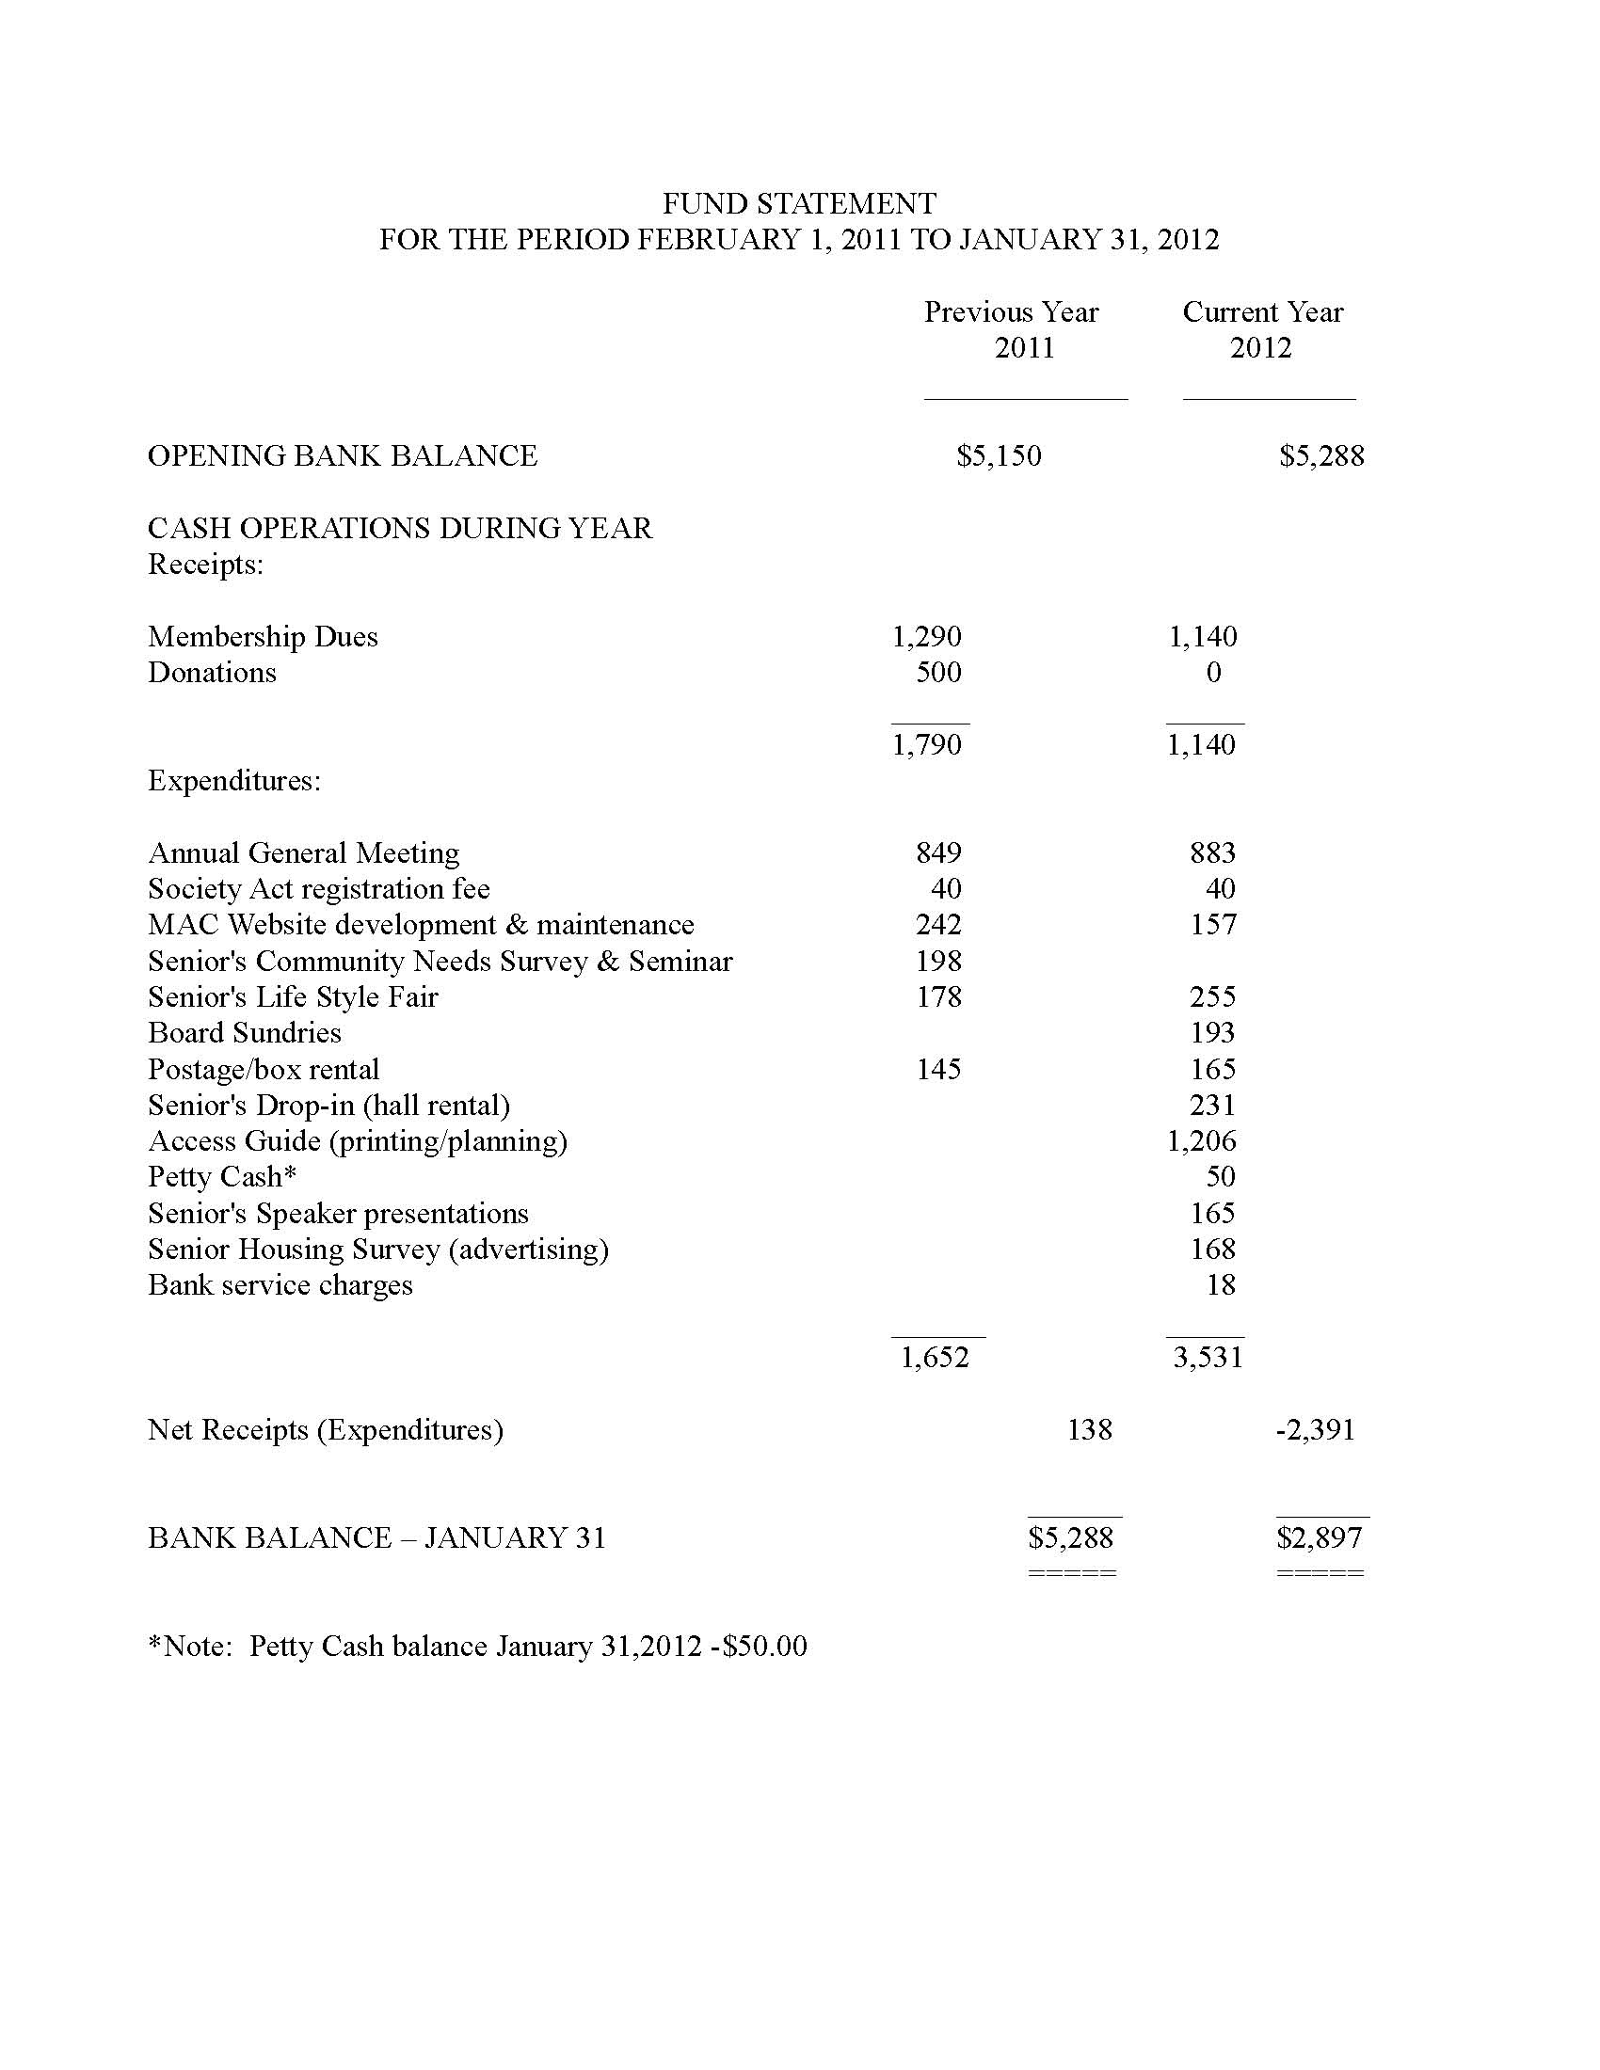It was moved by L. McKean, seconded by D. Armour, that the financial report be approved as circulated and presented. Motion carried.

**5.3 Nominating Committee Report** (Marg Pallot)

As required by MAC By-laws, the current Directors retired at this time. Director Pallot recognized Ivan Johnston for his service to MAC, and thanked David “Doc” Brown for his past year on the Board. Nominations for the upcoming year were submitted in response to the invitation circulated to all members as follows:

1. Three Year Term:
   1. Bob Calladine
   2. Bruce Hawkshaw
   3. Sue Lawther
2. Two Year Term:
   1. Gord Leidal
   2. Mag Pallot
3. One Year Term:
   1. Freda Cook
   2. Garry Watson
   3. Mark Watson

There was a further call for nominations from the floor. None were received.

It was moved by M. Pallot, seconded by L. McKean, that the nominations be approved. Motion carried.

The President, Vice President, Secretary and Treasurer will be appointed at the next Board meeting.

Thanks again to our retiring Board of Directors for their dedication and support over the past year.

**5.4 Membership Committee Report** (Marg Pallot)

It was reported that we currently have 245 members with a call going out to the community for new members. We have had 34 new members this year and would like to build on this trend. Many members have not yet paid, and those who are in arrears will be contacted by e-mail or phone.

The Board is recommending a small increase for the first time in 17 years. It was moved by M. Pallot, seconded by J. Pendygrasse to revise the fee structure effective February 1, 2013 to read:

1. $15 per single
2. $25 per couple

After discussion from the floor, the motion was amended by G.Watson and seconded by Carol Quinn to revise the fee structure to $15 per person effective February 1, 2013. Motion carried.

It was moved by D. Deeks to impose a special levy of $10 per person to all members effective August 2012. There was no seconder, and after discussion the motion was defeated.

It was moved by S. Lawther and seconded by J. Cook to accept the Membership Committee Report as given. Motion Carried.

**5.5 Senior Needs Action Planner Report** (Melissa Deller)

Melissa began her report with a job description:

*The Senior’s Needs Action Planner (S.N.A.P.) supports and enhances the quality of Whistler senior residents by* ***improving community linkages within health and social services, develops and delivers opportunities for social interaction and fosters partnerships with other community and health resources.*** *The S.N.A.P. worker will act as an information advocate and visionary information provider and advocate while lobbying for seniors needs within Whistler and the Sea to Sky Corridor.*

… and noted that when she started in June 2009 she was contracted for 16hrs per week. Today she is contracted for 36hrs per week which clearly reflects the need in the community.

Melissa’s past year has been busy:

* 1st reprint of the very successful Access Guide including the new Lifestyle Planning Guide

* Walking group start up

* Flu Clinic in conjunction with the Seniors’ Lifestyle Expo

* Snowshoe/winter walking start up

**What’s to come!**

* drop in weekly, featuring guest speakers monthly
  + specific programming
* Currently in discussion: Nigel Wakita, Director of Rec Education here at the Vancouver Circus School. Experience some programming. Classes are sure to tap into your artistic side, meanwhile offering fun and challenging work outs that will increase strength, flexibility, and motor skill development
* walking group will resume in June
* STAR- Transportation looking at Whistler and they will be work in supporting agencies in the important work of helping clients and members with transportation services. This is outside of WAVE and looking more at getting people to appointments in Vancouver.
* Opportunity to give me feedback about what you would like to see offered & participate in

Melissa ended her report with a quote from Muhammad Ali:

* ***Age is whatever you think it is. You are as old as you think you are.***

**6.0 GENERAL DISCUSSION AND QUESTIONS**

Another thank you to Don Armour, our webmaster. **There were 3200 visits to our website last year!**

**7.0 ADJOURNMENT**

Vice-Pres. Hawkshaw thanked the assembly for attending the meeting, acknowledged the retiring Directors for the contributions over the past year and welcomed the new Directors. The 16th meeting of the Mature Action Committee of Whistler was adjourned at 7:45 p.m.

It was moved by S. Lawther, seconded by G. Watson, that the meeting be adjourned. Motion carried.

A Special presentation was given after the Annual General Meeting by Ian Davis, LLB from Race and Co. on Estate Planning